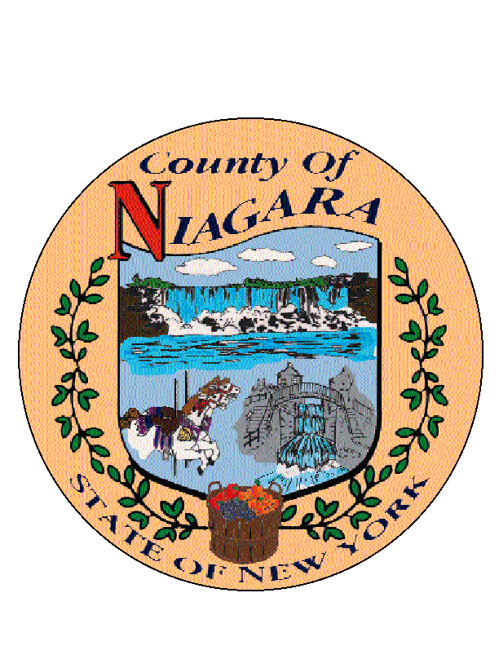
JOSEPH A. JASTRZEMSKI
County Clerk

MATTHEW L. PARISH
First Deputy County Clerk

(716) 439-7022
(716) 439-7035 Fax
NIAGARA COUNTY
COUNTY CLERK'S OFFICE
COURTHOUSE
P.O. BOX 461
LOCKPORT, NY 14095-0461
NN

2025 HOLIDAY SCHEDULE

NEW YEAR’S DAY |  | JANUARY 1, 2025 |  | WEDNESDAY
MARTIN LUTHER KING JR. DAY |  | JANUARY 20, 2025 |  | MONDAY
PRESIDENTS’ DAY |  | FEBRUARY 17, 2025 |  | MONDAY
GOOD FRIDAY |  | APRIL 18, 2025 |  | FRIDAY
MEMORIAL DAY |  | MAY 26, 2025 |  | MONDAY
INDEPENDENCE DAY |  | JULY 4, 2025 |  | FRIDAY
LABOR DAY |  | SEPTEMBER 1, 2025 |  | MONDAY
COLUMBUS DAY |  | OCTOBER 13, 2025 |  | MONDAY
VETERANS DAY |  | NOVEMBER 11, 2025 |  | TUESDAY
THANKSGIVING DAY |  | NOVEMBER 27, 2025 |  | THURSDAY
DAY AFTER THANKSGIVING |  | NOVEMBER 28, 2025 |  | FRIDAY
CHRISTMAS DAY |  | DECEMBER 25, 2025 |  | THURSDAY

